Spring 2023

SIDRA
Creative Brief

Table of Contents
Brand Name 3
Purpose of the IMC Campaign/Creative Brief 3
Purpose of Brand 3
Purpose Statement 3
Values Statements 3
People: Target Market Description 4
Problem 4
Problem Statement 4
User Story 4
Brand Marketing Mix 5
Place Strategy 5
Price Strategy 5
Product Strategy 5
FAB PIE 5
Brand Value Proposition 6
Positioning Statement 6
Potential 6
Marketing Objective(s) (MO) 6
Communication Objective(s) (CO) 6
Persuasion 6
Tagline 6
Brand Elements 7
Common Brand Associations 7
Colors 7
Fonts 7
Logo 8
Tagline 8
Tone 8
Five Senses Brand Associations 8
Look 8
Smell 8
Sound 8
Taste 9
Feel 9
Citations 10

Brand Name
SIDRA

Purpose of the IMC Campaign/Creative Brief
I’m graduating soon and will be in search of an employer looking for someone to help spread their brand image. To find a position with a company I believe in, I’ll first need to be established in my personal brand.

Purpose of Brand

Purpose Statement
To help businesses increase their reach and awareness using creativity and kindness so that they can grow and reach as many people as possible.

Values Statements
Brand Value | Meaning
Kindness | Treat all with respect but do not accept disrespectful treatment.
Equity and Fairness | Fight for human rights and the environment.
Supportive | Encourage everyone’s goals and beliefs, so long as those goals/beliefs don’t harm others.
Appreciative | Find the value in the littlest of things.
Humble | Don’t lose sight of yours and others’ value.
Growth-mindset | Continually search for ways to improve and grow.

People: Target Market Description
B2B: Small Businesses or Organizations
Customer Segment and Problem | Business owner (of small businesses) or hiring director/marketing director with the desire to expand company reach/knowledge among their target market.
Firmographics | Company Age: new/young  Size: small – less than 100 employees  Industry: local outdoor parks department, sustainable-focused, human rights/social justice, art, music, café/bar
Firm Psychographics | Company Values: kindness and respect, clear communication, humility, teamwork, promote from within
Firm Geographics | Blaine to Seattle; anywhere if remote
Usage Rate | Low – minimal marketers
Usage State | Medium – some experience with marketing
Benefits Sought | Seen, known, recognized, liked/loved

Problem

Problem Statement
I’m a company trying to increase my reach across the market but am struggling to do so because I’m not sure where to start, making me feel stressed.
I’m a company trying to increase my likability and preference across the market but am struggling to do so due to lack of know-how, making me feel frustrated.

User Story
Cynthia, a local restaurant owner, would like to increase knowledge of her business to 60% and liking to 40% and extend her business to a second location in the south Bellingham area.

Brand Marketing Mix

Place Strategy
Bellingham, WA and Seattle, WA area
In-person and remote
- Networking events
- Career fairs
- Personal website

Price Strategy
I would like to find an entry-level position that is close to a $50k salary. By January 1st, 2025, I would like to be making a $60k salary or greater.

Product Strategy

FAB PIE
Customer Benefits Sought | Product Physical Features | Product Intellectual Advantages | Product Emotional Benefits
Quick-learning, innovative, motivated, creative marketing employee | Relaxed yet professional clothing, good hygiene | Marketing Degree from WWU | Kind, love, supportive, helpful

Brand Value Proposition
I help people better-market their brand through my own inner creativity.

Positioning Statement
For companies who are seeking to better-market their brand,
Sidra is the only marketer that provides creative and innovative solutions,
unlike other applicants, because of her experience and knowledge.

Potential

Marketing Objective(s) (MO)
Marketing Objective #1: Increase revenue from $18k yearly to $80k by January 1st, 2025.
Marketing Objective #2: Grow website visits from 0 to 10 monthly by December 31st, 2023.

Communication Objective(s) (CO)
Brand Objective Areas | Numerical Target |  | By (mm/dd/yyyy)
Brand Objective Areas | Current Level | New Level | By (mm/dd/yyyy)
Awareness | 0% | 30% | 12/31/2023
Knowledge | 0% | 20% | 12/31/2023
Liking | 0% | 10% | 12/31/2023
Preference | 0% | 5% | 12/31/2023

Persuasion

Tagline
Inspire kindness.

Brand Elements

Common Brand Associations

Colors
Photo to create photo palette taken from wedding.
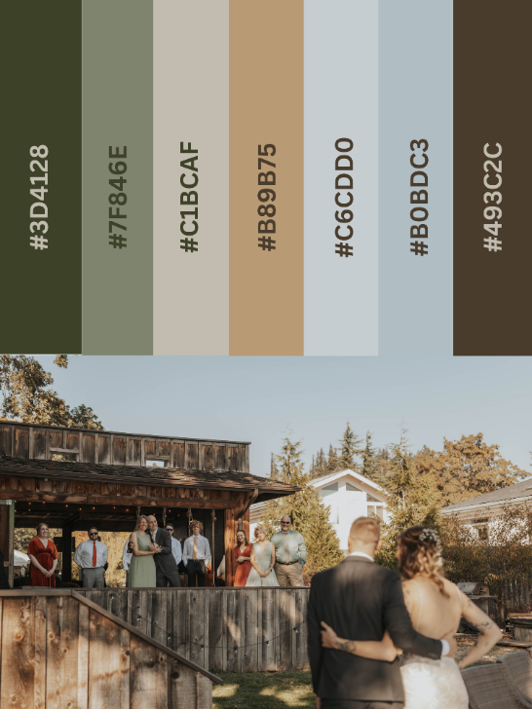

Fonts
Headings – Montserrat
Text – Libre Franklin

Logo
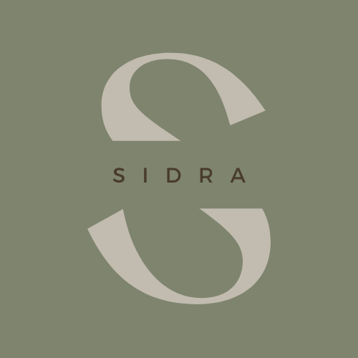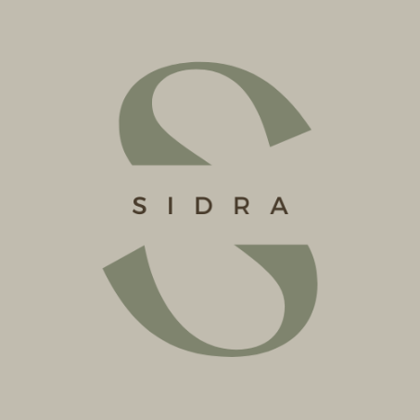

Tagline
Inspire kindness.

Tone
Humorous, genuine, joyful, grateful, kind, warm, trustworthy, gentle, honest

Five Senses Brand Associations

Look
Happy; comforting; golden hour; starry night sky with a full moon

Smell
Soil just after a rainstorm; fresh-cut grass; warm laundry; coffee and tea; books

Sound
Songbirds on a summer morning; crickets and frogs at night; waves breathing in and out against the rocks; acoustic guitar drifting through the breeze on a cool summer night; raw vocals in an empty room

Taste
Coffee and tea; sweet and salty melting over your tongue; cold, crisp water at 2am; a cold beer after sweating in the sun

Feel
The feeling of lush grass on your feet; burying your feet into rough sand; curling up in a soft and cozy blanket by a fire on a cold, snowy day; sitting down after a long day on your feet; your happiest day; your parent carrying you to bed after being lulled asleep by the rocking of the car when you were a child; loved and seen

Citations
Turner, J. (2022, June 6). What Marketing Budgets Look Like in 2022. gartner.com. Retrieved June 2, 2023, from https://www.gartner.com/en/articles/what-marketing-budgets-look-like-in-2022

