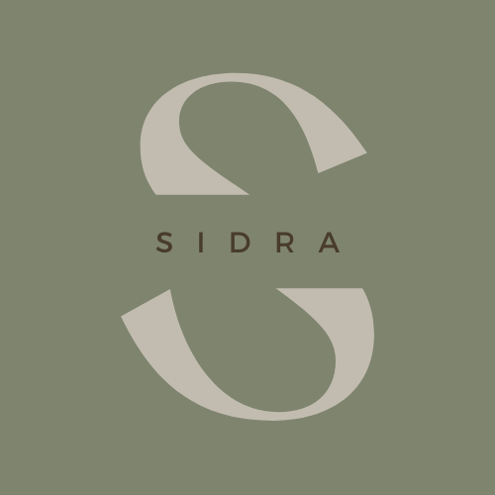

Sidra Knaus

Experience

Feb 2021 – present
Host/Server • The Birch Door Café, Bellingham, WA

June 2023 – Aug 2023
Project Manager • WWU MKTG 488 IMC Class

Jan 2020 – May 2020
Education Intern • Red River Zoo, Fargo, ND

Mar 2016 – Jan 2021
Barista Trainer • Starbucks, Hood River, OR & Bellingham, WA

Education

Western Washington University, Bellingham, WA
- Bachelor of Arts in Business Administration – Marketing concentration
- Minors in Entrepreneurship and Innovation and Music

Certifications
Spotify Digital Audio Foundations
Spotify Intro to Ad Studio

skills
Integrated Marketing Communications
Agile & Scrum
Teams & Slack
Hootsuite
WordPress

References
Available upon request.
 | Birch Bay, Washington
 | 509.637.6474
 | sidra.knaus@gmail.com
 | sidraknaus.com

Objective
To support your company in connecting with the community so that we can create greater, long-lasting change.

